Hybrid RAG Knowledge Assistant
Major Project Report
Submitted in partial fulfillment of the requirements for the award of the degree of
BACHELOR OF TECHNOLOGY
IN
COMPUTER SCIENCE AND ENGINEERING
SUBMITTED BY:
ABHAY MAURYA (221620101001) VARUN RANA (221620101059) SAMIR AHMAD (731620101005) | AMIT YADAV (221620101010)  SHANU AHMED (731620101003)
Under the able guidance of
Assistant Prof. Mrs. Sneh Lata Singh
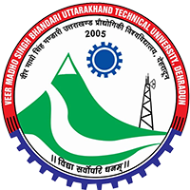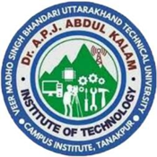
DEPARTMENT OF COMPUTER SCIENCE AND ENGINEERING
DR. A.P.J. ABDUL KALAM GOVERNMENT INSTITUTE OF TECHNOLOGY TANAKPUR (CHAMPAWAT, UTTARAKHAND) – 262309
(CAMPUS INSTITUTE OF)
VEER MADHO SINGH BHANDARI UTTARAKHAND TECHNICAL UNIVERSITY, DEHRADUN
February – July, 2026

